**ASSIGNMENT 2**

**1. Select Your Operating System (OS)**

**Choose and Install Windows 11:**

1. **Visit the Microsoft Windows 11 Download Page:**
   * Open your web browser and go to [Download Windows 11](https://www.microsoft.com/software-download/windows11).
2. **Check System Requirements:**
   * Ensure your computer meets the system requirements for Windows 11. You can use the PC Health Check tool available on the download page.
3. **Download Windows 11 Installation Assistant:**
   * On the download page, click on the “Download now” button under the “Windows 11 Installation Assistant” section.
4. **Run the Installation Assistant:**
   * Once downloaded, open the file and follow the on-screen instructions to upgrade your current operating system to Windows 11 or perform a fresh installation.
5. **Follow Installation Steps:**
   * Follow the guided steps to complete the installation. This includes selecting your language, time, and keyboard preferences, entering your product key, and configuring privacy settings.

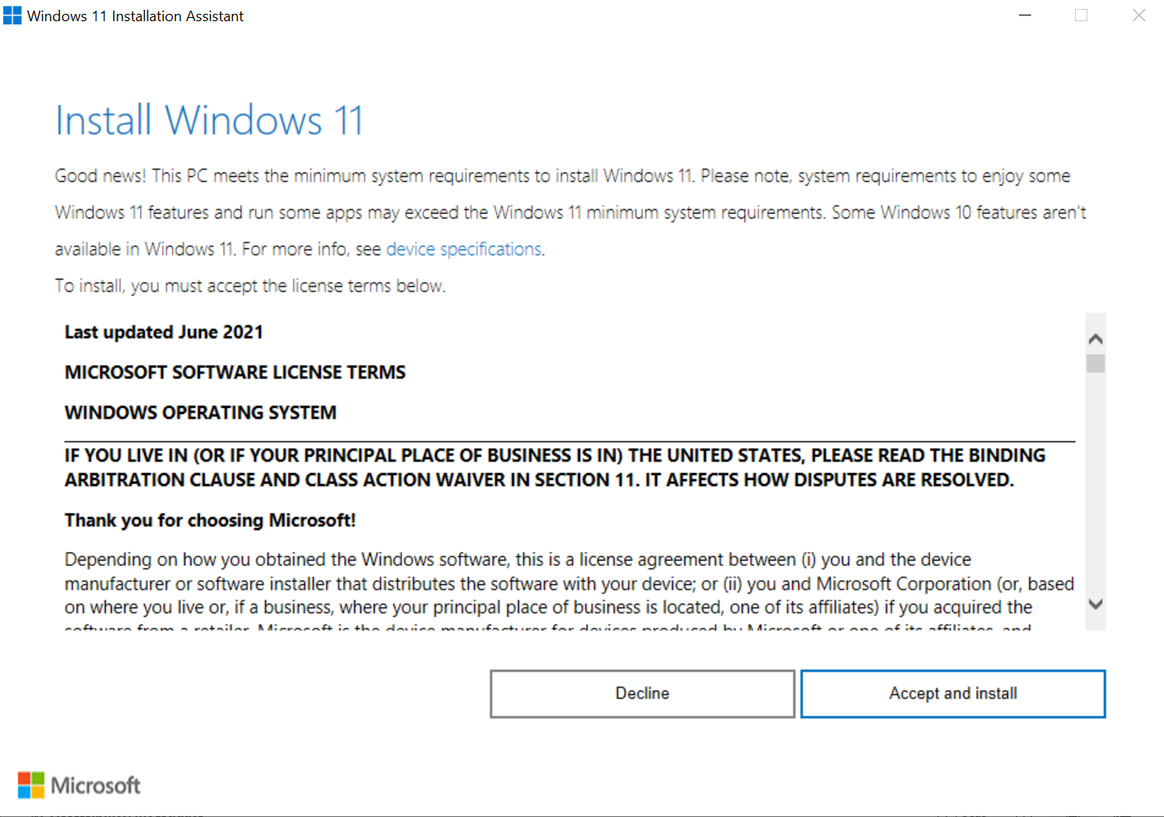

**2. Install a Text Editor or Integrated Development Environment (IDE)**

**Download and Install Visual Studio Code:**

1. **Visit the Visual Studio Code Download Page:**
   * Open your web browser and go to [Download Visual Studio Code](https://code.visualstudio.com/Download).
2. **Select the Windows Version:**
   * Click on the “Windows” button to download the installer.
3. **Run the Installer:**
   * Once the download is complete, open the installer file (VSCodeUserSetup-x64-<version>.exe).
4. **Follow the Setup Wizard:**
   * Agree to the license terms and follow the setup wizard. You can select additional tasks such as creating a desktop icon and adding VS Code to the PATH for easier access from the command line.
5. **Complete Installation:**
   * Click “Install” and then “Finish” once the installation is complete.

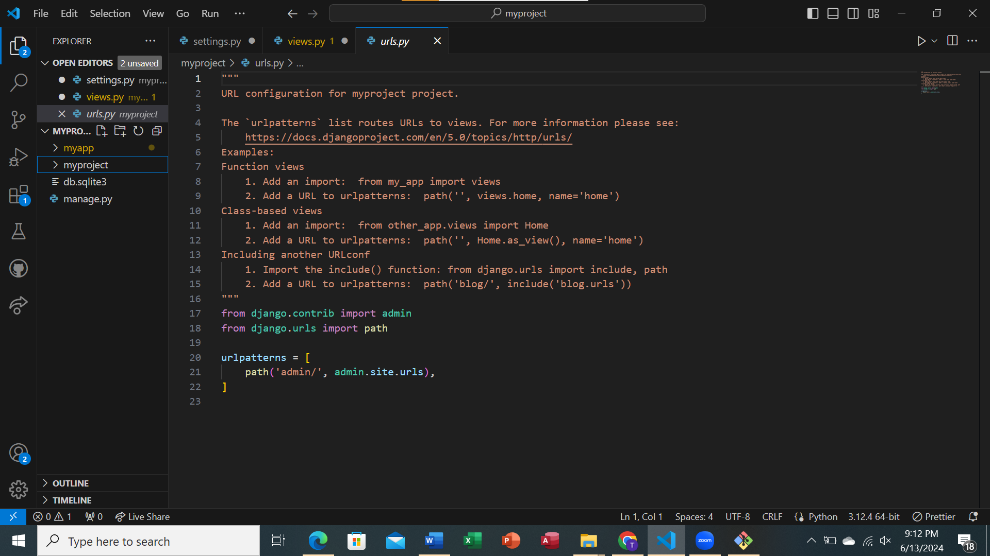

**3. Set Up Version Control System**

**Install Git:**

1. **Visit the Git Download Page:**
   * Go to [Download Git](https://git-scm.com/download/win).
2. **Download the Git Installer:**
   * Click on the “64-bit Git for Windows Setup” link to download the installer.
3. **Run the Installer:**
   * Open the downloaded installer (Git-<version>-64-bit.exe).
4. **Follow the Setup Wizard:**
   * Accept the GNU General Public License.
   * Select the components you want to install (use the default options unless you have specific preferences).
   * Configure the editor used by Git (you can choose Visual Studio Code here).
   * Adjust your PATH environment (use the recommended option).
   * Configure the remaining options based on your preferences (e.g., line ending conversions, terminal emulator to use, etc.).
5. **Complete Installation:**
   * Click “Install” and then “Finish” once the installation is complete.

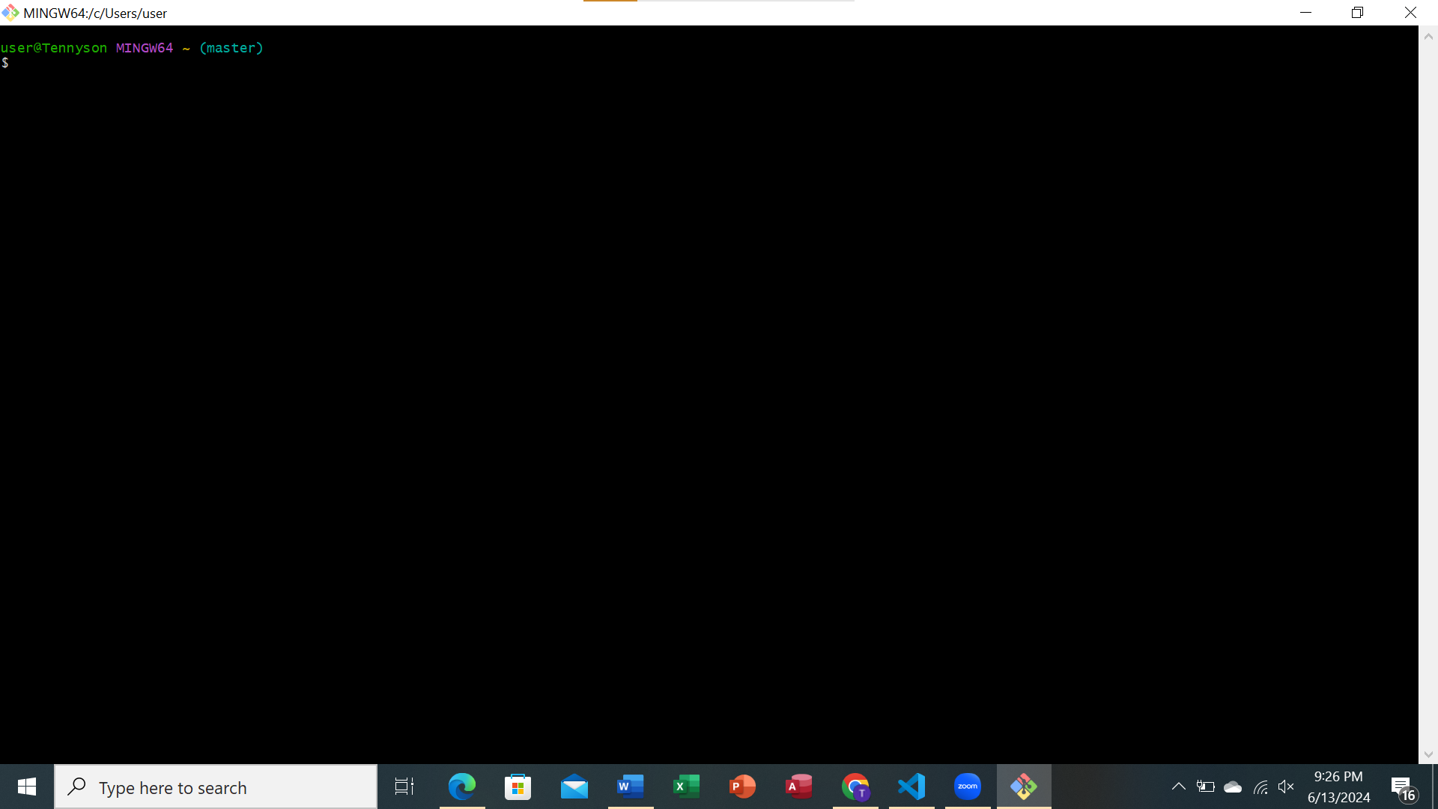

**Create a GitHub Account:**

1. **Sign Up on GitHub:**
   * Go to [GitHub](https://github.com) and click on the “Sign up” button.
   * Follow the steps to create your account, including verifying your email address.

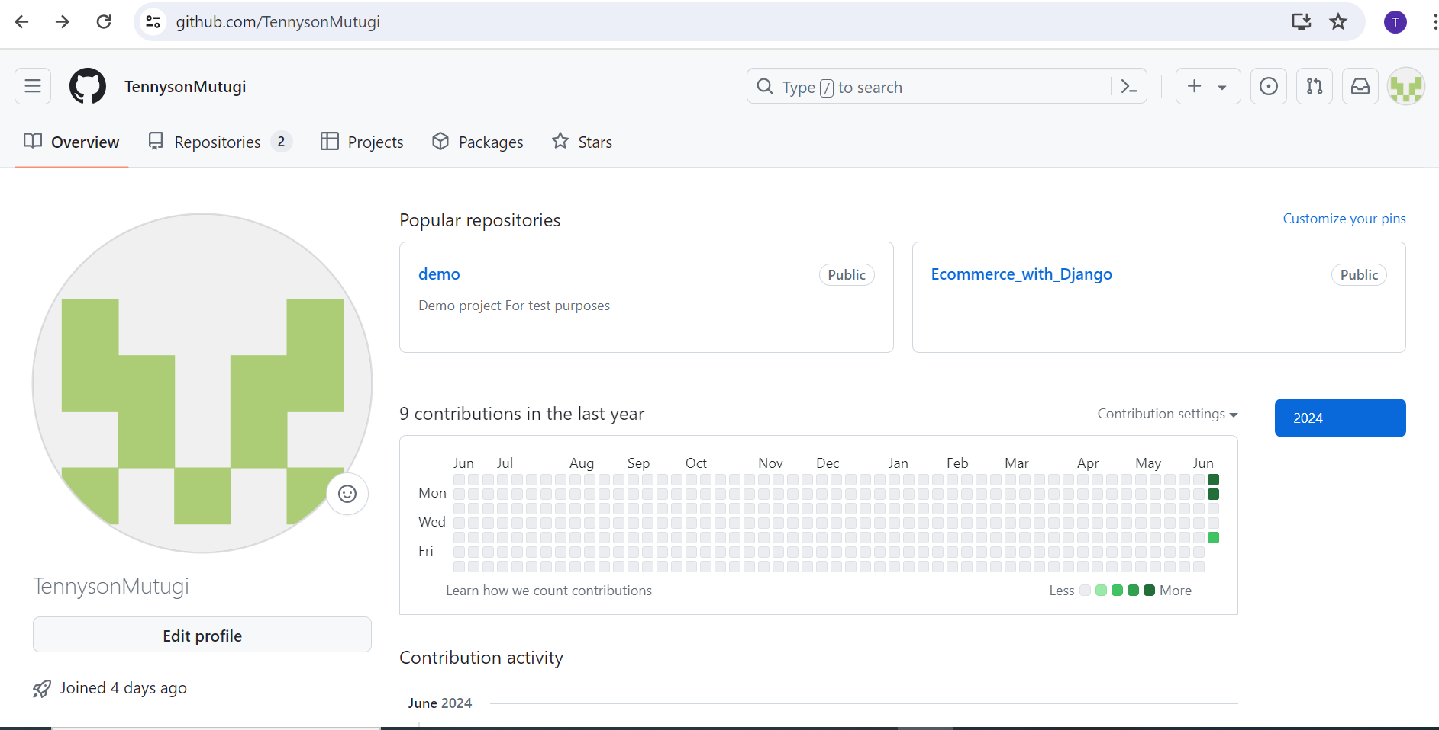

**Initialize a Git Repository:**

1. **Open Git Bash:**
   * After installing Git, open Git Bash from the Start menu or search for it in the taskbar.
2. **Navigate to Your Project Directory:**
   * Use the cd command to navigate to the directory where your project is located or create a new directory:

Cd: c/

Mkdir

cd

1. **Initialize a Git Repository:**
   * Run the following command to initialize a new Git repository

git init

1. **Stage and Commit Your Project Files:**
   * Add all your files to the staging area:

git add .

* + Commit the files with an initial commit message:

git commit -m "Initial commit"

1. **Add a Remote Repository:**
   * Create a new repository on GitHub by clicking the “New” button on your GitHub dashboard.
   * Do not initialize the repository with a README, .gitignore, or license.
   * Copy the repository URL and add it as a remote in your local repository:

git remote add origin https://github.com/your-username/your-repo.git

1. **Push Your Changes to GitHub:**
   * Push the initial commit to GitHub:

git push -u origin master

**4. Install Necessary Programming Languages and Runtimes**

**Install Python:**

1. **Visit the Official Python Website:**
   * Go to [Download Python](https://www.python.org/downloads/).
2. **Download the Latest Python Installer:**
   * Click on the “Download Python <version>” button to download the installer for Windows.
3. **Run the Installer:**
   * Open the downloaded file (python-<version>.exe).
4. **Follow the Setup Wizard:**
   * Make sure to check the “Add Python to PATH” option at the bottom of the setup window.
   * Click “Install Now” and follow the installation steps.
5. **Verify the Installation:**
   * Open Command Prompt or PowerShell and run:

python --version

* + You should see the installed Python version.

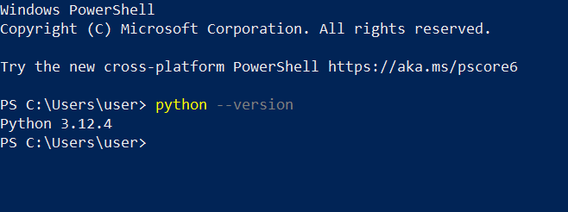

**5. Install Package Managers**

**Verify pip Installation:**

* pip is included with Python installations. To verify, open Command Prompt or PowerShell and run:

pip –version

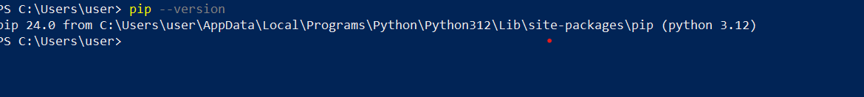

**6. Configure a Database (MySQL)**

**Download and Install MySQL:**

1. **Visit the MySQL Download Page:**
   * Go to [Download MySQL](https://dev.mysql.com/downloads/windows/installer/5.7.html).
2. **Download the MySQL Installer:**
   * Click on the “Download” button for the MySQL Installer.
3. **Run the Installer:**
   * Open the downloaded file (mysql-installer-community-<version>.exe).
4. **Follow the Setup Wizard:**
   * Choose the setup type (typically “Developer Default”).
   * Click “Next” and follow the steps to install MySQL Server and other components.
   * Configure your MySQL server, including setting a root password and creating a user.
5. **Complete Installation:**
   * Finish the setup and make note of your root password and any users you create.

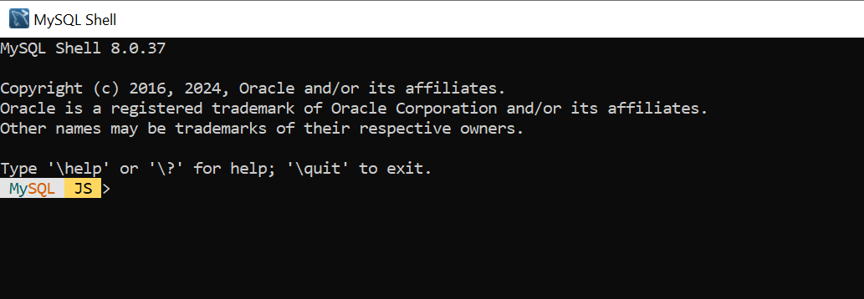

1. **Verify Installation:**
   * Open MySQL Workbench (installed with MySQL) and connect to your MySQL server using the root credentials.

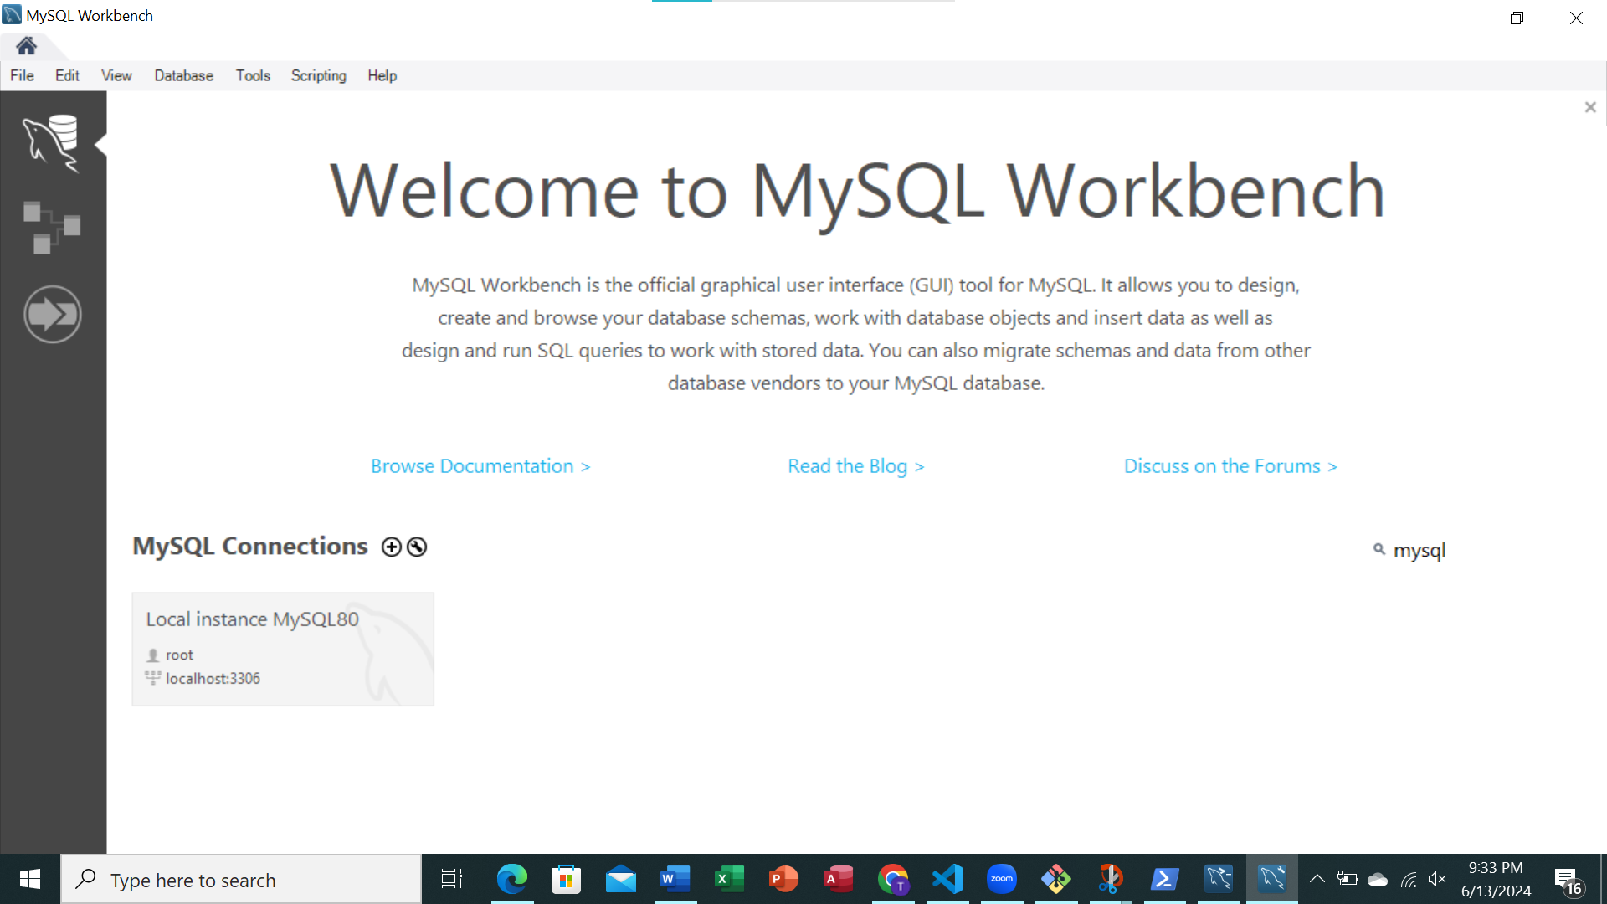

**7. Set Up Development Environments and Virtualization (Optional)**

**Consider Using Docker:**

1. **Visit the Docker Website:**
   * Go to Download Docker.
2. **Download Docker Desktop for Windows:**
   * Click on the “Download for Windows” button.
3. **Run the Installer:**
   * Open the downloaded file (Docker Desktop Installer.exe).
4. **Follow the Setup Wizard:**
   * Follow the installation steps and restart your computer if prompted.
5. **Complete the Setup:**
   * After installation, Docker Desktop should start automatically.
   * Follow the initial setup instructions and complete the configuration.

**8. Explore Extensions and Plugins**

**Install Visual Studio Code Extensions:**

1. **Open Visual Studio Code:**
   * Launch VS Code from the Start menu or taskbar.
2. **Open the Extensions View:**
   * Click the Extensions icon in the Activity Bar on the side of the window or press
3. **Search and Install Extensions:**
   * Use the search bar to find and install the following recommended extensions:
     + **Python** (by Microsoft): Provides support for Python development.
     + **GitLens** (by GitKraken): Enhances Git capabilities.
     + **Prettier - Code Formatter** (by Prettier): Formats your code.

